**Academic year 2020-2021**

**Promotion: B1 Switch IT**



**Campus Contest**

**B1 Switch IT**

**17 and 18 December 2020**

Table des matières

1. Introduction 3

1.1 Purpose of the work experience for the learner 3

1.2 Campus Contest Calendar 3

1.3 Terms & Conditions 3

1.4 Evaluations 3

2. Background : Christmas Tree 4

2.1 Achievement Criteria 4

2.2 Expected returns : Team Workflow 4

2.3 Level 1 – The 3-storeys tree 5

Algorithm of Level 1: 5

2.4 Level 2 – Trunk 7

Algorithm of Level 2: 7

2.5 Level 3 – Tinsel 8

Algorithm of Level 3: 8

2.6 Level 4 – Christmas baubles 10

Algorithm of Level 4 : 10

2.7 Level 5 – The Death Star ! 12

Algorithm of Level 5 : 13

2.8 Bonus 1 – A bigger tree ! 15

2.9 Bonus 2 – Lot of trees ! 16

3. Computer Fundamentals rendering 17

3.1 Deliverables (Word Document) : 17

3.2 Bonus (au choix, fournir POC et doc) : 26

4. Grille de correction 27

5. Appendix : List of emails 28

# Introduction

# Purpose of the work experience for the learner

To implement the skills acquired during training by reinvesting what you have learned in a professional situation in relation to a simple need: to design the Campus Academy Christmas tree.

# Campus Contest Calendar

17 and 18 December 2020.

# Terms & Conditions

In groups of two. Deliver collaboratively using GIT and by dropping your rendering on GitHub or GitLab for example. The groups were generated randomly.

|  |  |  |  |
| --- | --- | --- | --- |
| Surname | Name | Promotion | Random |
| CIVILE | Nicola | ANG Switch IT – Bachelor 1 | 0,036 |
| SÉGALEN | Thomas | ANG Switch IT – Bachelor 1 | 0,107 |

# Evaluations

For each dedicated period, you will be evaluated on your progress and deliverables. You will find the final evaluation form at the end of this document.

# Background : Christmas Tree

Christmas is approaching and animals have broken into Campus Academy’s premises to steal Christmas trees. Animals also celebrate Christmas with a tree and do not like it when humans cut down their trees. Compassionate, the students decided to do without Christmas trees from the forest. Super smart, they will use a 3D printer to get their tree.

For this, the Switch IT team is requisitioned to develop a program that will draw on the screen a Christmas tree.

# Achievement Criteria

- Your Python program must be able to be executed on the command line:

Ex: python3 my_program.py Same with arguments Ex: python3 my_program.py argument_1

- **Prohibition to add "hard" trees in your cde**

- The use of PEP8 and flake8 code style is strongly recommended.

- A strong appreciation will be added for a code in English (no variable name with accents etc...).

- For each Python3 program, a rendering of an algorithm is expected. Use the pseudo-code learned and/or any other form that allows the corrector to understand your approach.

# Expected returns : Team Workflow

With your partner, you must work in collaboration. For this, GIT is mandatory. Also make sure to deposit your code on GitHub.

Your project must include :

- Regular commits

- A clean and formatted README.md markdown file (French or English)

# Level 1 – The 3-storeys tree

Using an algorithmic solution, write a program that allows you to draw a 3-story tree on the screen.

The tree should look like the following figure:

Analyze the shape of the tree and the number of "*".

### Algorithm of Level 1:

Start

n = 4

height = n

stars_nb = 1

spaces_nb = height – 1

For i 0 to height

Print (“ ” + spaces_nb * “ “ + stars_nb * “*”)

stars_nb += 2

spaces_nb -= 1

stars_nb = 3

spaces_nb = height – 1

For i 0 to height

Print (“ ” + spaces_nb * “ “ + stars_nb * “*”)

stars_nb += 4

spaces_nb -= 1

stars_nb = 5

spaces_nb = height – 1

For i 0 to height

Print (spaces_nb * “ “ + stars_nb * “*”)

stars_nb += 6

spaces_nb -= 1

End

# Level 2 – Trunk

After printing it in 3D, the students realized that a trunk was missing to make it fit!

Add to the program the part to draw a trunk like the figure below:

### Algorithm of Level 2:

Start

n = 4

height = n

# Method 1

stars_nb = 5

spaces_nb = height – 1

For i 0 to height – 1

For j 0 to 2

Print (spaces_nb * “ “ + stars_nb * “*”)

# Method 2

For i 0 to height – 1

Print (“ ” + “*****”)

End

# Level 3 – Tinsel

Super happy, you manage to deliver the plans of the trees for 3D printing. And what's more, the trees are standing upright!

Nevertheless, one of the teachers makes the following remark: "It would be prettier with garlands! »

You must now add garlands at the bottom of the tree:

### Algorithm of Level 3:

Start

n = 4

height = n

stars_nb = 5

spaces_nb = height - 1

For i 0 to height – 1

If i == 0

For j 1 to 14

If j < 5

Print (” |”, end = ””)

Elif j >= 5 and j <= 9

If j == 5

Print (” *”, end = ””)

Else

Print (”*”, end = ””)

Else

Print (” |”, end = “”)

Elif i == 1

Print (“”)

For j 1 to 14

If j < 5

Print (“ 0”, end = “”)

Elif j >= 5 and j <= 9

If j == 5

Print (“ *”, end = “”)

Else

Print (“*”, end = “”)

Else

Print (“ 0”, end = “”)

Else

Print (“”)

For i 0 to height – 3

Print (spaces_nb * “ “ + stars_nb * “*”)

End

# Level 4 – Christmas baubles

Don't do the job halfway, now that you've left for decoration, you'll have to decorate the top!

Add balls at the ends of the levels (except the last one who has the garlands) :

### Algorithm of Level 4 :

Start

n = 4

height = n

# Method – Stage 2 / Christmas balls

stars_nb = 3

spaces_nb = height – 1

For i 0 to height

If stars_nb == 3

Print (“ ” + spaces_nb + “ “ + “0 “ + stars_nb * “*” + “ 0”)

stars_nb += 4

spaces_nb -= 1

Else

Print (“ ” + spaces_nb * “ ” + stars_nb * “*”)

stars_nb += 4

spaces_nb -= 1

# Method – Stage 3 / Christmas balls

stars_nb = 5

spaces_nb = height – 1

For i 0 to height

If stars_nb == 5

Print (spaces_nb * “ ” + “ 0 ” + stars_nb * “*” + “ 0 “)

stars_nb += 6

spaces_nb -= 1

Else

Print (spaces_nb * “ ” + stars_nb * “*”)

stars_nb += 6

spaces_nb -= 1

End

# Level 5 – The Death Star !

This time, without any external request, the students decided to add the Death Star.

In reality, it's just a star for the tree but the students used their imagination and named their star Death Star.

So, add this star as shown in the figure below:

### Algorithm of Level 5 :

Start

n = 4

height = n

stars_nb = 1

spaces_nb = height – 1

For i 0 to 7

If i == 0

Print (””)

Print (“ ”, end = “”)

For j 0 to 11

If j == 0 or j == 10

Print (” * ”, end = “”)

Elif j == 5

Print (”*”, end = ””)

Else

Print (“ ”, end = “”)

If i == 1

Print (“”)

Print (“ ”, end = “”)

For j 0 to 11

Print (“ ”, end = “”)

If j == 5

Print (“*”, end = “”)

Else

Print (“ ”, end = “”)

If i == 2

Print (“”)

For j 0 to 11

Print (“ ”, end = “”)

If j == 5

Print (“*”, end = “”)

Else

Print (“ ”, end = “”)

If i == 3

Print (“”)

Print (“ ”, end = “”)

For j 0 to 11

If j == 0 or j == 2 or j == 4 or j == 6 or j == 8 or j == 10

Print (“*”, end = “”)

Else

Print (“ ”, end = “”)

If i == 4

Print (“”)

For j 0 to 11

Print (“ ”, end = “”)

If j == 5

Print (“*”, end = “”)

Else

Print (“ ”, end = “”)

If i == 5

Print (“”)

Print (“ ”, end = “”)

For j 0 to 11

If j == 2 or j == 8

Print (“ * “, end = “”)

Elif j == 5

Print (“|”, end = “”)

Else

Print (“ ”, end = “”)

If i == 6

Print (“”)

Print (“ ”, end = “”)

For j 0 to 11

If j == 0 or j == 10

Print (“ * “, end = “”)

Elif j == 5

Print (“|”, end = “”)

Else

Print (“ ”, end = “”)

Print (“”)

End

# Bonus 1 – A bigger tree !

Teachers who find you super motivated decide to give you a bonus if you manage to modify your algorithm and therefore your program to design different sized trees!

Your program could accept a parameter that from it will generate a tree with a corresponding number of storeys.

Example with the following figure:

# Bonus 2 – Lot of trees !

To save money, you decide to print several trees at once. To do this, your program must be able to draw several trees on the same line!

Modify your program accordingly Ex with the following figure:

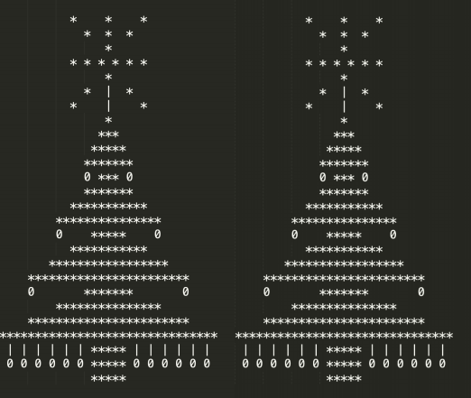

# Computer Fundamentals rendering

In addition to the Git in binomial, you decide for reasons of security and confidentiality to set up your own private GIT. Indeed, reindeer accompanied by an individual dressed in red, is trying in this period to steal the source code of Christmas tree like Python Project. Beware, some of the requested manipulations may not be feasible. It is up to you to justify.

# Deliverables (Word Document) :

* Documentation of the installation of a Git on a local VM (Windows and/or Linux) protected by a PFSENSE router - 10 points

Création d’une machine virtuelle : CA-WINDOWS

Machine virtuelle de Génération 2

Mémoire affectée à la machine virtuelle : 4096 Mo

Mise en réseau via Ethernet : EXT-FILAIRE

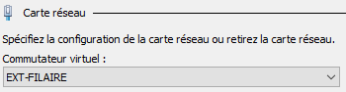

Stockage virtuel dédié : 41 Go

ISO : Windows Server 2016

Création du routeur virtuel : CA-PFSENSE

Routeur virtuel de Génération 1

Mémoire affectée au routeur virtuel : 4096 Mo

Mise en réseau via Ethernet : EXT-FILAIRE



Stockage virtuel dédié : 40 Go

ISO : pfSense 2.4.5

Installation de GIT sur la machine virtuelle :

Création d’un service IIS :

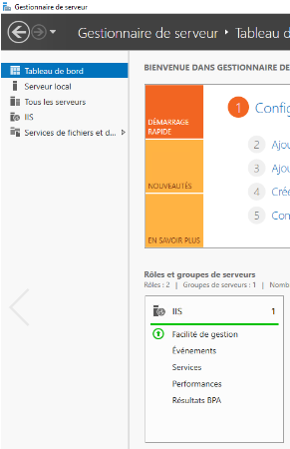

Nom du site : GIT  
Chemin d’accès physique : Répertoire « ChristmasTree » créé dans le disque C:\

Port : 8090

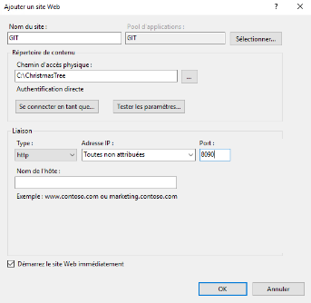

Répertoire GIT : ChristmasTree

* Proof of concept de fonctionnement de votre infrastructure – 7 points

Ping sur l’IP 8.8.8.8 afin de tester l’accessibilité de notre routeur

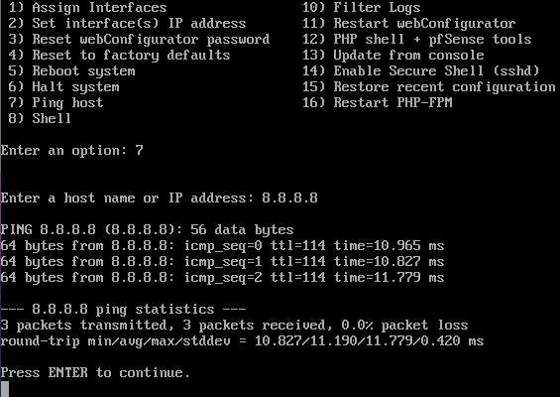

Ping sur l’IP de notre machine virtuelle afin de tester l’accessibilité de celle-ci

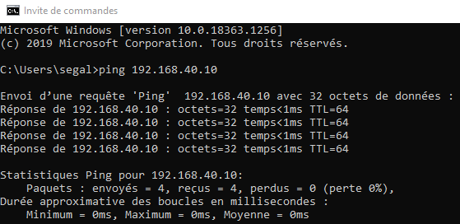

Connexion au panel pfSense :



Avec comme identifiant : admin et mot de passe : pfsense



Changement de notre mot de passe

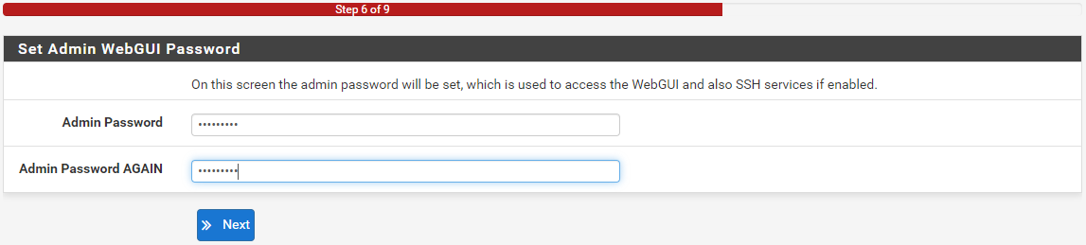

Dashboard pfSense :

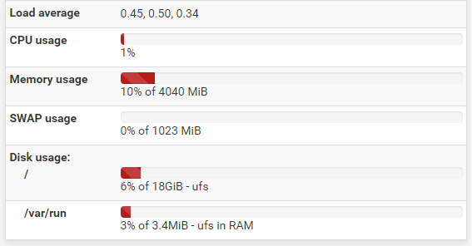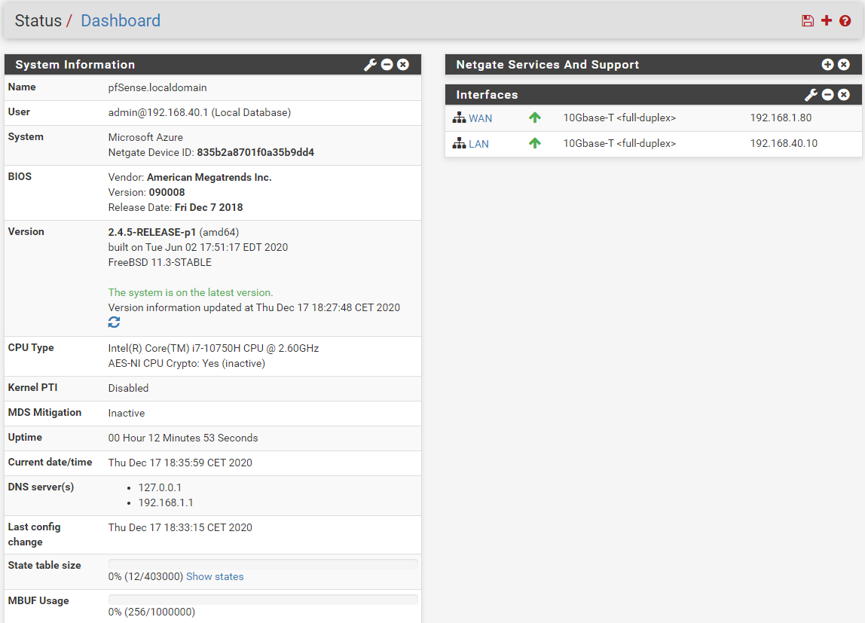

* Proof of concept de mise en ligne de votre code – 3 points

# Bonus (au choix, fournir POC et doc) :

* Santa Claus in the clouds - Setting up a GIT in the Azure Cloud VM from portal.azure.com - 5 points

Docs : <https://docs.netgate.com/pfsense/en/latest/solutions/azure-appliance/index.html>

* Confined Christmas - From the home of one the members, gain access to the GIT of the other member through his box - 5 points

# Grille de correction

Promotions : **Bachelor 1**

Filière : **Switch IT**

|  |  |  |
| --- | --- | --- |
| **Livrables fournis :** | **Barème** | **Points** |
| Programme Python3 (3pts) + algo du niveau 1 (1pts) : Le sapin à 3 étages | 4 |  |
| Programme Python3 (4pts) + algo du niveau 2 (1pts) : Tronc | 5 |  |
| Programme Python3 (4pts) + algo du niveau 3 (1pts) : Guirlandes | 5 |  |
| Programme Python3 (4pts) + algo du niveau 4 (1pts) : Boules de noël | 5 |  |
| Programme Python3 (4pts) + algo du niveau 5 (1pts) : L’étoile de la mort | 5 |  |
| Documentation de l’installation d’un Git sur un VM locale (Windows et/ou Linux) protégée par un routeur PFSENSE | 10 |  |
| Proof of concept de fonctionnement de votre infrastructure | 7 |  |
| Proof of concept de mise en ligne de votre code | 3 |  |
| **TOTAL** | **44** |  |

|  |  |  |
| --- | --- | --- |
| **Compétences techniques :** | **Barème** | **Points** |
| Le code est propre | 2 |  |
| Le programme Python3 est fonctionnel | 1 |  |
| Chaque niveau comporte programme python3 + algorithme | 3 |  |
| Le code respecte les bonnes pratiques de développement | 2 |  |
| Des commits réguliers avec des messages courts et appropriés | 3 |  |
| Un fichier README.md propre et formaté markdown pour chaque niveau | 2 |  |
| **TOTAL** | **13** |  |

|  |  |  |
| --- | --- | --- |
| **Compétences transverses :** | **Barème** | **Points** |
| Implication dans le rendu et la collaboration pour mener à bien le challenge | 3 |  |

**Total : / 60**

|  |  |  |
| --- | --- | --- |
| **Bonus :** | **Barème** | **Points** |
| Programme Python3 : Un sapin plus grand ! | 4 |  |
| Programme Python3 : Beaucoup de sapins ! | 4 |  |
| Mise en place du git dans une VM en Cloud Azure | 5 |  |
| Accès d’un git du membre de son équipe à travers sa box | 5 |  |

**Total avec bonus : / 60**

**Note :** Cette grille d’évaluation est liée au travail de groupe ou binôme, mais elle n’oblige pas l’évaluateur à renseigner la même note à tous les membres du groupe. Par conséquent, il est possible de trouver des différences de note d’un apprenant à l’autre.

* Les documents doivent être accessibles par le correcteur.

# Appendix : List of emails

The following list of emails should be added to your GIT folders on GitHub.

This list corresponds to your potential correctors and for that, an access is mandatory!

k.niel.pro@gmail.com